Enrolling in the online textbook

1. Use the Safari browser and search for: sso.cpm.org

2. You should be on a page that looks like this:

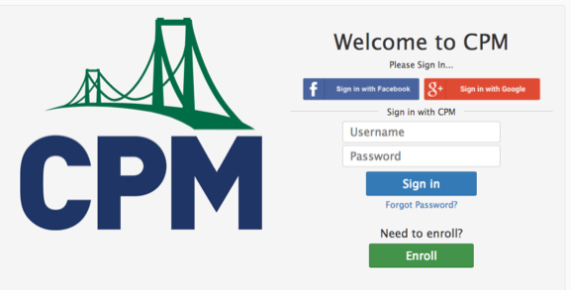

3. Click on the green ENROLL button on the bottom of the page. After this one time initial enrollment process, you will be using the red SIGN IN WITH GOOGLE button. Do not try to enroll using the blue FACEBOOK or blue SIGN IN buttons.

4. You should be on a page that looks like this:

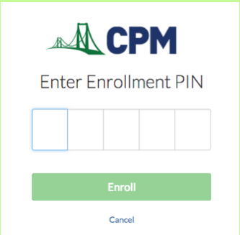

You need to enter the enrollment PIN for my math classes. That PIN is: R6TJD

5. You should now be on a very long and wordy page that is the license agreement to use the CPM ebook. Scroll down to the bottom of the page and click on “I agree”.

6. You should now be on a page with pictures of two different CPM math books, one in English and one in Spanish. You want the Common Core 1 book on the left which is in English. You are now basically there.

7. Now you want to take the extra step to bookmark or save your LOG IN screen. Most kids like to create an icon on their home screen for the book. To do this you will need to: 1) Go back to sso.cpm.org on Safari so that you are at the LOG IN screen ; 2) Click on the sharrow key on the top right of the screen. It’s the key that looks like a square with an arrow coming out of it; 3) A little screen will pop up. On that screen go to the fourth choice on the bottom row, the one that looks like a rounded gray square with a plus sign in the middle of it; and 4) Click on ADD and it will add an icon to the home screen that will take you right into the LOG IN screen in the future. And remember, you will always log in using the red LOG IN WITH GOOGLE button from here on in.

8. YOU DID IT! (If not come and see me and we’ll figure it out.)

