Study Guide for the Last Test of the year, 2018 Name: _________________

Class: __________________

Date: _________________

1. Find the Volume and Surface Area of the rectangular prism below. Show all of your steps and include appropriate labels.

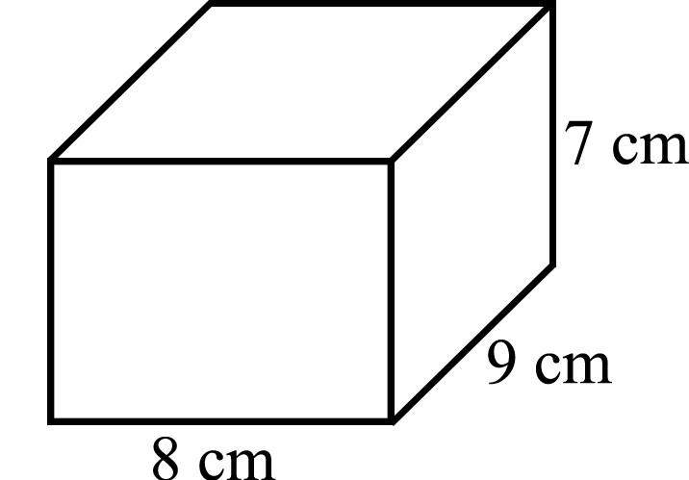

Volume: ____________ SA: _______________

1. Rewrite (using parentheses) and valuate each of the expressions below using the following values. Box your Answers!

*a =* 6 *b =* -3 *c =* -2 *d* = 4

a)   b)   c) 

d)   e)   f) 

g)  h)  i) 

3. Measures of Central Tendency and a Frequency Table

1. Students in a lucky class were asked how many Giants games they had attended during the summer. Their answers are listed below.

4 , 3 , 8 , 2 , 3 , 7 , 4 , 1 , 6 , 2 , 3 , 7 , 3 , 4 , 3

Use the table below to create a frequency table.

|  |  |  |
| --- | --- | --- |
| Number of Games | Frequency of Number of Games | Total of Number of Games  Attended |
| 1 |  |  |
| 2 |  |  |
| 3 |  |  |
| 4 |  |  |
| 5 |  |  |
| 6 |  |  |
| 7 |  |  |
| 8 |  |  |

b. What are the mean, median, mode, and range of the data set?

Mean: ______ Median: ______ Mode: ______ Range: _______

1. Are there outliers in this data set? How do you know?
2. Another child joined the class. He had also attended several Giants games but the mean of the data set remained the same. How could that be? Determine how many games had he attended. Write a sentence explaining why the mean didn’t change. Did the median or mode change? Write two sentences explaining why or why not.
3. Box Plots

Use the following data to create a box plot in the space below.

8, 40, 14, 12, 35, 72, 33, 14, 66, 28, 41, 9, 53, 10, 50, 16, 35, 42, 70

­­­­­­­­­________________________________________________________

a. Median _____ Lower Quartile _____ Upper Quartile _____ IQR ______

b. Is the data set symmetric? How can you tell from the box plot?

5. Common Measurements:

a) How many feet are in 4 miles? __________

b) How many ounces are in 8 pounds? __________

c) How many minutes are in 2 days? __________

d) How many inches are in 4 yards? __________

e) How many fluid ounces are in 3 cups? __________

f) How many yards are in a mile? __________

g) How many pints are in 5 gallons? __________

h) How many fluid ounces are in 3 quarts? __________

i) How many tons are equal to 12,000 pounds? __________

j) How many seconds in 15 minutes? __________

k) What temperature does water boil in Fahrenheit? __________

l) In what century is the year 1111 CE? __________

m) What temperature does water freeze in Fahrenheit? _________

1. Find the area and perimeter of the figure below:

Area: ___________ Perimeter: ___________

1. Annie had a bag of 480 M&M’s. One sixth were red, 20% were yellow and .15 were green. How many of the M&M’s were other colors?